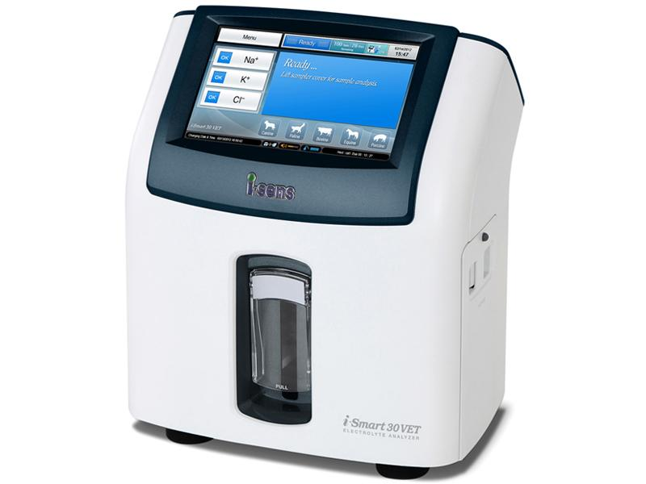

POC104 - QC Testing for iSens iSmart 30VET

Outline

The purpose of this document is to outline how to perform quality control (QC) testing for the iSens iSmart 30VET electrolyte analyser. The document details how to load the tri-level control values into the analyser’s memory, prepare the analyser and sample for testing, run the test, and finally send the result to Vepalabs via the POC web portal.

QC testing is a critical function in any laboratory for assessing the accuracy and precision of results, using benchmarked, known target values. Vepalabs uses results collected nationally in order to monitor the performance of supported hardware, identify outlier results and individual analyser drift, and address any issues before they become clinically problematic.

Required Materials

- iSens iSmart 30VET;
- i-Smart Electrolyte Quality Control (tri-level)
- Nitrile gloves;
- Laboratory PC with ‘Lab Integration Client’ installed;
- Internet connection.

Method

- Ensure that the Laboratory Integration Client is running on the connected PC. There will be a desktop shortcut to open the application, which may need restarting after a loss of internet connection, restart, power outage or other incident. The telltale flask icon () should be visible either in the Windows taskbar, or in the icon stack in the lower right hand corner.

- On the iSmart, press Menu, then Full Menu, Setup and finally QC Setup to open the QC Setup page. If there is already data loaded into the analyser, select each level individually, and press ‘Delete’ to delete the old QC data.

- Select the now empty Level 1 field, and press ‘Add’, then ‘QC Barcode’ from the next screen. Using the attached barcode scanner, scan the respective Level 1 barcode found on the product insert within the Electrolyte Quality Control package. The analyser will check and accept the relevant data, after which, press the ‘OK’ button, and repeat this step for Level 2 and Level 3.

- Press ‘OK’ to save all data and return to the main screen.

- From the main screen, press ‘Run QC’ and again on the next screen.

- When the analyser instructs you to do so, lift the sampler cover to expose the sample probe, and select ‘Level 1’ from the selection screen.

- Prepare your Level 1 sample by inverting the bottle several times, removing the cap and squeezing out a small amount of control fluid into an appropriate sample cup. Vepalabs recommends using a plain microtube (red capped) with the plastic pellet removed. Immerse the sample probe into the Level 1 control, and press ‘Aspirate’.

- When prompted, remove the QC sample from the sampler probe, then close the sampler cover.

- After analysis is complete, press ‘Accept’ to accept the results generated, and if automatic sending is disabled press ‘Send’ to send the test result through to the lab integration PC.

- Repeat steps 7-9 for Level 2 and Level 3, ensuring that the control is tested as soon as possible after dispensing from the squeeze bottle.

- Open the Vepalabs web portal (poc.vepalabs.com.au) and find, then open the coloured QC results within the list of ‘pending’ results. If the result cannot be found, confirm that the laboratory integration client is running on the PC.

- Confirm that the results match the results from the analyser, and click the ‘Send Test Result Now’ button at the bottom of the screen.

- You have completed the QC testing process. Congratulations!

PLEASE NOTE THESE STORAGE REQUIREMENTS
Storage: Refrigerate the vial (please put well inside the fridge, not the fridge door)
Expiry (unopened): Refer to expiry date on packaging
Expiry (after opening): 10 weeks after opening. Please discard after this point.

If you have any queries or concerns, please contact the Vepa team immediately on 1300 837 252

Method Revision History
Version | Date | Authorised by | Notes
1 | 01/07/2017 | PH | Initial method
2 | 03/08/2017 | JM | Additions, storage reqs
3 | 5/12/2017 | PH | Formatting

